Amarilda Celhaka

Assignment #7

5/6/2019

CMP SCI 4250

Function 1 displays:

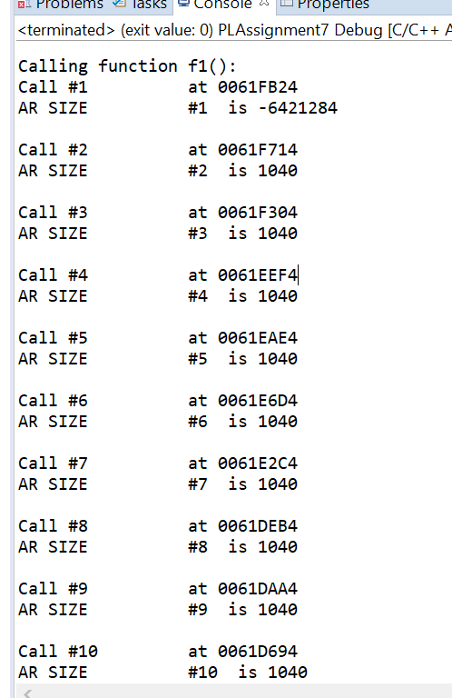

Function 2 displays towards the end:

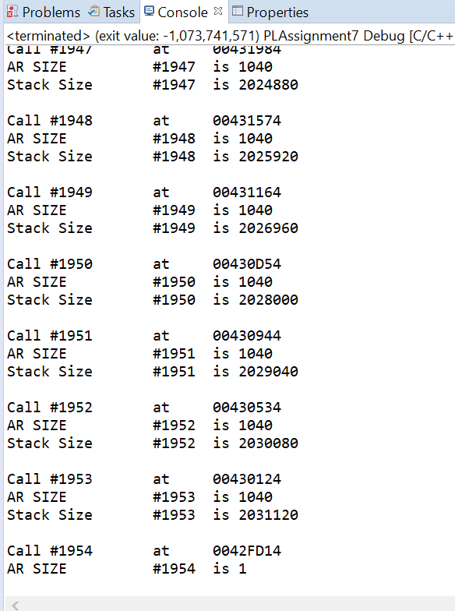

Function f3() displays:

